Executive Summary
Investors rely on financial ratios derived from financial statements to decide on what shares to buy, sell or hold, and when and how much. However, these ratios have limitations as a result of the way the financial statements are prepared. One limitation results from window dressing – when management reports financial transactions to enhance the attractiveness of the financial statements.
As regards the company in point, based on the financial ratios Babushkas’ Baubles plc performed relatively worse than Benny’s Blings plc although both of their performances declined from 2007 to 2008. Based on further analysis of Babushka’s financial performance, it is recommended that no investment be made for the company.
Lastly, this recommendation does have its own limitations. Given the fact that no additional information was provided, the conclusion and recommendation resulting from the ratio analysis didn’t take into account accounting practices adopted by Babushka and its future prospects in the industry.
Introduction
Financial statement analysis had become standard for investors in determining whether to invest in a company or not. Point in case: this report recommending whether Babushka’s Baubles plc is a good investment or not. First is, however, who are the users of financial statement analysis?
There are two main user groups of financial statement and its analysis: the internal users and the external users. Examples of internal users are management and employees while external users are shareholders, creditors, government agencies, suppliers and customers among others. Generally, these groups use financial statements and their analyses to:
- facilitate decision making. For example, a shareholder analyses the financial statements of a company to decide whether to buy, sell or hold the shares of the company.
- monitor performance. Managers use financial statements of the different divisions of their company to review the performance of their employees, and this review could be one of the factors used to determine a employee’s performance bonus for a given period.
- interpret contracts and agreements. Employees use financial statements to review their demands such as increase in salary.
However, the emphasis of this report is the specific uses of financial statements with respect to investors such as existing and prospective shareholders. Specifically, investors use financial statements and their analysis including ratio analysis to facilitate decision making on what, when and how much shares to buy, retain or sell. By using ratio analysis, investors can examine trends within the company and compare its financial performance with its peers.
Investors, in doing careful financial statement analysis, compute ratios from these statements. These ratios are generally grouped into:
- Liquidity ratios which include current, quick and cash ratios. These ratios give an indication on the ability and capability of the company to meet short term obligations.
- Activity ratios which include receivables turnover and days outstanding, inventory turnover and days outstanding, and payable turnover and days outstanding. These ratios indicate how efficient and effective the company is in using its resources to generate cash.
- Profitability ratios which include profit and gross margin percentages, return on assets and equity and earnings per share. Profitability ratios help investors determine how effective and efficient a company is in generation additional shareholder wealth.
- Leverage ratios which include the ratios of debt relative to total assets and equity, interest coverage ratio and times interest earned. These ratios show how the assets of the company are financed and whether the company is highly levered or not.
However, relying too much on financial ratio analysis in deciding what, when and how much to invest is not advisable. Financial ratios by themselves have limitations. A fundamental limitation is the way financial statements themselves are prepared. Generally accepted accounting principles allow companies to choose what accounting treatment to use in recording their transactions. For example inventory can be valued by using the first-in, first-out or FIFO, weighted average and specific identification methods. Hence, comparing the financial performance of two companies which use different inventory methods is like comparing an apple with an orange. Another example is companies can also use different depreciation method – straight line, sum-of-the-years’-digits, double declining, etc. – while still not violating generally accepted accounting principles.
Moreover, managements of companies also engage in what is commonly called as window dressing. Window dressing is when the management of companies prepare financial statements with the intention of presenting the financial operations and transactions of the companies in a more attractive tone rather than merely reporting what is. Window dressed financial statements can distort the conclusions and recommendations based on the ratios calculated from such statements.
Management, having control of the operations of a company, has the discretion on its financial transactions. Management, in order to present more attractive financial results, can postpone necessary expenditures. For example, to increase net income, managers might postpone advertising expenses which, in the long run, is detrimental to the company.
Another key limitation is the characteristic of financial statements themselves. Financial statements present the results of the past and current operations of a company. Hence, the ratios based from these statements would also be on past transactions. In investment decisions, the immediate and long term prospects of the company are as important as their historical performance, sometimes even more important.
An investor must take into account all the above limitations of financial statement analysis specifically financial ratios when deciding on what companies to buy, sell or hold, and on when and how much.
Analysis
As shown in Table 1, Babushka’s Baubles plc’s revenues decrease by $30,000,000 from 2007 to 2008. This shows a 6.67 per cent drop. A look at the company’s net income for the same period shows a drop of more than 38 per cent! This, given the other ratios for Babushka, shows a worsening management performance and control over the company’s resources.
Moreover, other financial ratios of the company such as its profitability, liquidity and activity ratios show a declining trend in the company’s overall performance. As shown in Table 2, in spite of a relatively low decrease in the company’s gross profit margin, the net profit margin percentage and rate of return on capital employed by the company decreased at a faster rate.
Furthermore, as displayed in Table 3, aside from the company’s declining profitability performance, it is also having difficulty in converting its assets, specifically inventories and receivables, into cash which it needs to pay its trade payables. As a result of its slower conversion of inventory to receivables to cash, its quick and current ratios declined during the year. Another thing is that the company pays its trade payables much earlier than it receives cash for its trade receivables. If this trend continues, the company would need additional funding to finance its working capital requirements.
Conclusion
From the above analysis, I conclude that Babushka is not a profitable investment if the intention of the investment is to generate growth in the short term. However, if the investor intends to take an active role in the management of the company and is willing to sacrifice short term gains for the possibility of long term gains, then an investment in the company can be profitable. For a long term investment, the investor, as the new management, needs to make immediate and drastic reorganization and restructuring of Babushka’s Baubles plc to ensure that assets are use efficiently and effectively.
Given the above conclusion, I recommend that no investment is made for Babushka Bauble’s plc. A long term investment, although can be profitable, is not viable because of the need to take an active role in the management of the company – a role which the investor can not assume.
Limitations of the above recommendation are:
- No additional information is given with regard to Babushka’s Baubles plc and Benny’s Bling plc’s accounting methods for inventory and depreciation. Hence, no adjustments were made on the financial statements to come up with more accurate and reliable ratios.
- No additional information is given on the immediate and long term prospects of Babushka. An investment recommendation based purely on the historical performance of Babuska’s Baubles plc is short sighted.

Appendix
Table 1Financial Ratio Comparison
 | Babushka |  | Benny
 | 2008 | 2007 | 2008 | 2007
Revenue | 420,000 | 450,000 | 30,000 | 25,000
Net profit before interest | 16,000 | 26,000 | 1,710 | 1,500
Capital employed | 120,100 | 118,100 | 22,000 | 21,000
Return on capital employed | 9% | 15% | 8% | 7%
Net profit margin | 2.52% | 3.93% | 5.70% | 6.00%
Gross profit margin | 11.4% | 12.0% | 25% | 26%
Inventory period | 118 | 115 | 22 | 20
Trade receivables period | 30 | 28 | 46 | 42
Trade payables days | 85 | 80 | 26 | 22
Current ratio | 1.8 | 1.8 | 1.7 | 1.8
Acid test | 0.42 | 0.41 | 0.8 | 0.8
Gearing ratio | 8% | 8% | 50% | 55%

Table 2 Babushka's Baubles plc: Profitability Trend
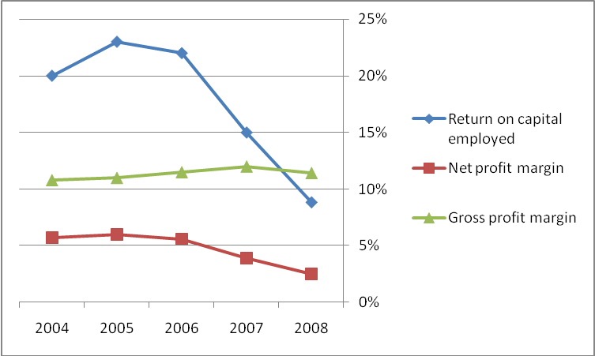

Table 3 Babushka's Baubles plc: Activity Trend
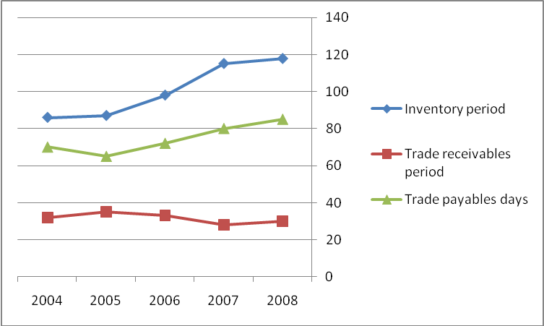

Table 4 Babushka's Baubles plc: Liquidity Trend
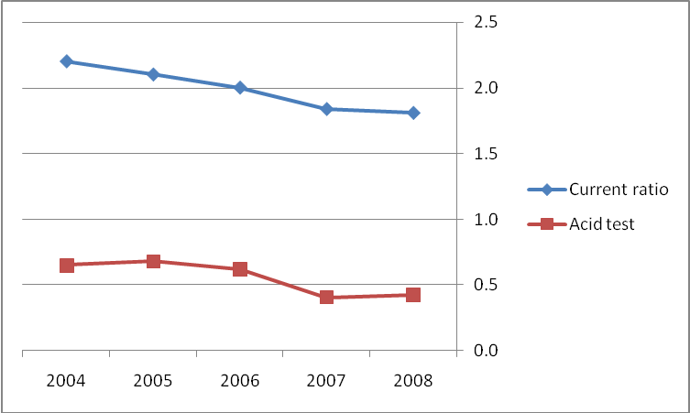

Including balance sheet, income statement, statement of comprehensive income, statement of cash flows, statement of changes in stockholders’ equity, and footnotes and supplementary data.

